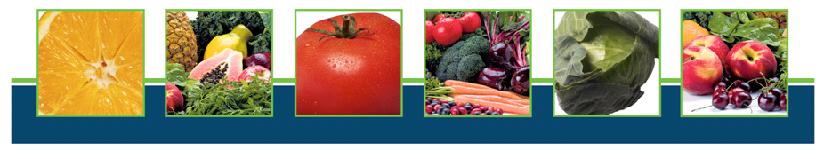

Health Education Lecture

Doctors’ Medical Panel

Nutrition, Wellness and Longevity

*Dr. John Saran, MD, Internal Medicine, Moderator*

*Dr. Mark Benjamin, MD, Opthalmologist*

*Dr. Anita Balodis, MD, Family Practice & Holistic Medicine*

*Dr.Candace Corson, MD, Family Medicine/ Integrative Medicine*

*Dr. Justin Hunter, DC, DCBCN, Clinical Nutrition*

*Dr. John Lloyd, Ph.D. Associate Professor of Biology*

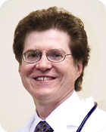 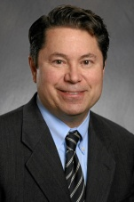  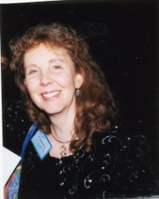 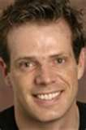 [](http://www.google.com/imgres?um=1&hl=en&sa=N&biw=1920&bih=963&tbm=isch&tbnid=Yka6UWANdXrMYM:&imgrefurl=http://www.aurora.edu/academics/programs-majors/undergraduate/biology/john-lloyd.html&docid=OTCdGX85dJ6ujM&imgurl=http://www.aurora.edu/images/academics/faculty/lloyd.jpg&w=180&h=275&ei=NHd_UNDrFaKOyAGuzYDoAQ&zoom=1&iact=hc&vpx=184&vpy=138&dur=750&hovh=220&hovw=144&tx=94&ty=107&sig=103241261267269309310&page=1&tbnh=141&tbnw=92&start=0&ndsp=43&ved=1t:429,r:0,s:0,i:72)

Friday, November 30, 2012 7:00pm

**Hyatt Hotel**

**1400 Corporetum Drive**

**Lisle, IL 60532**

**FREE for Guests of Nutrition, Connection Balance/Valerie Early RD**

**Register today by calling NCB at 847-985-1200 or** [**rosanne@nutritionconnectionbalance.com**](mailto:rosanne@nutritionconnectionbalance.com)

[**www.nutritionconnectionbalance.com**](http://www.nutritionconnectionbalance.com)

**Sponsored by Prevention Chicago**

