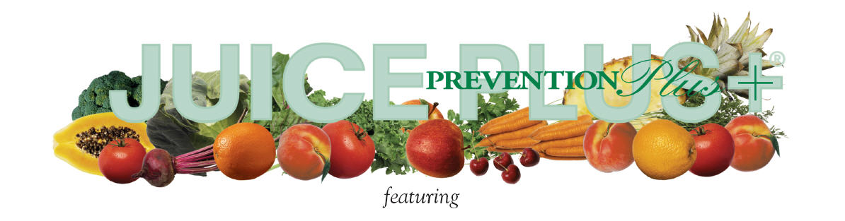

NUTRITION IN HEALTHCARE

Join us for a breakfast presentation & learn…
- What many of us didn’t learn in school about the power of nutrition for disease prevention
- Why thousands of professionals around the world are recommending Juice Plus+ to their patients and loved ones

Dr. Kim Dalzell, Ph.D., R.D., Moderator
Dr. Devang Patel, D.O.
Michael Koziol, L.A.C.
Mary Terdich, R.N.
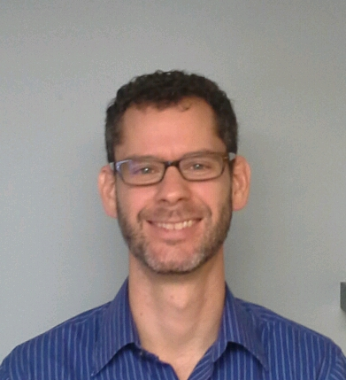
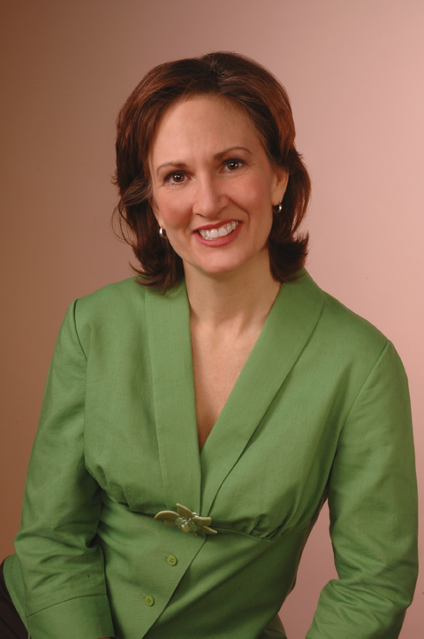
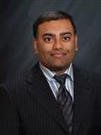
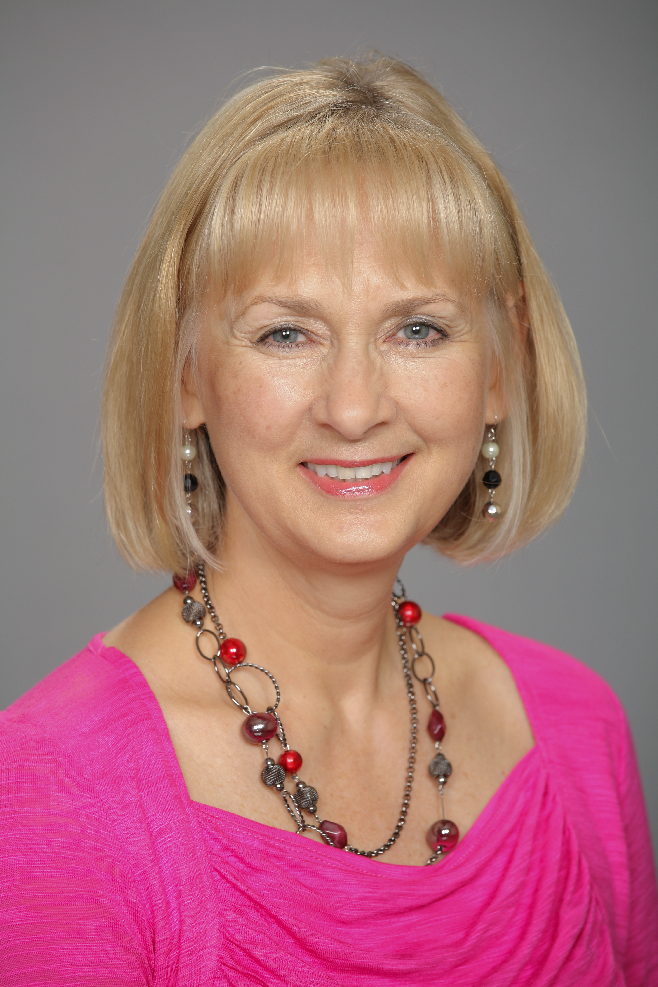

Friday, January 18, 2013 ~ 7:00–8:00 am
(Check-in at 6:45 am)
Holiday Inn Chicago Northwest
495 Airport Road; Elgin, IL 60123

Breakfast Buffet Served - $15

Seating is limited to Healthcare Professionals ONLY.
Please RSVP by Tuesday, January 15 2013, to Valerie Early, RD to reserve your seats and bring your healthcare staff and friends in the medical field.
Register by calling Rosanne at NCB @ 847-985-1200 or by text directly to Valerie @ 847-346-7314 or by e-mail valerieearly@comcast.net

