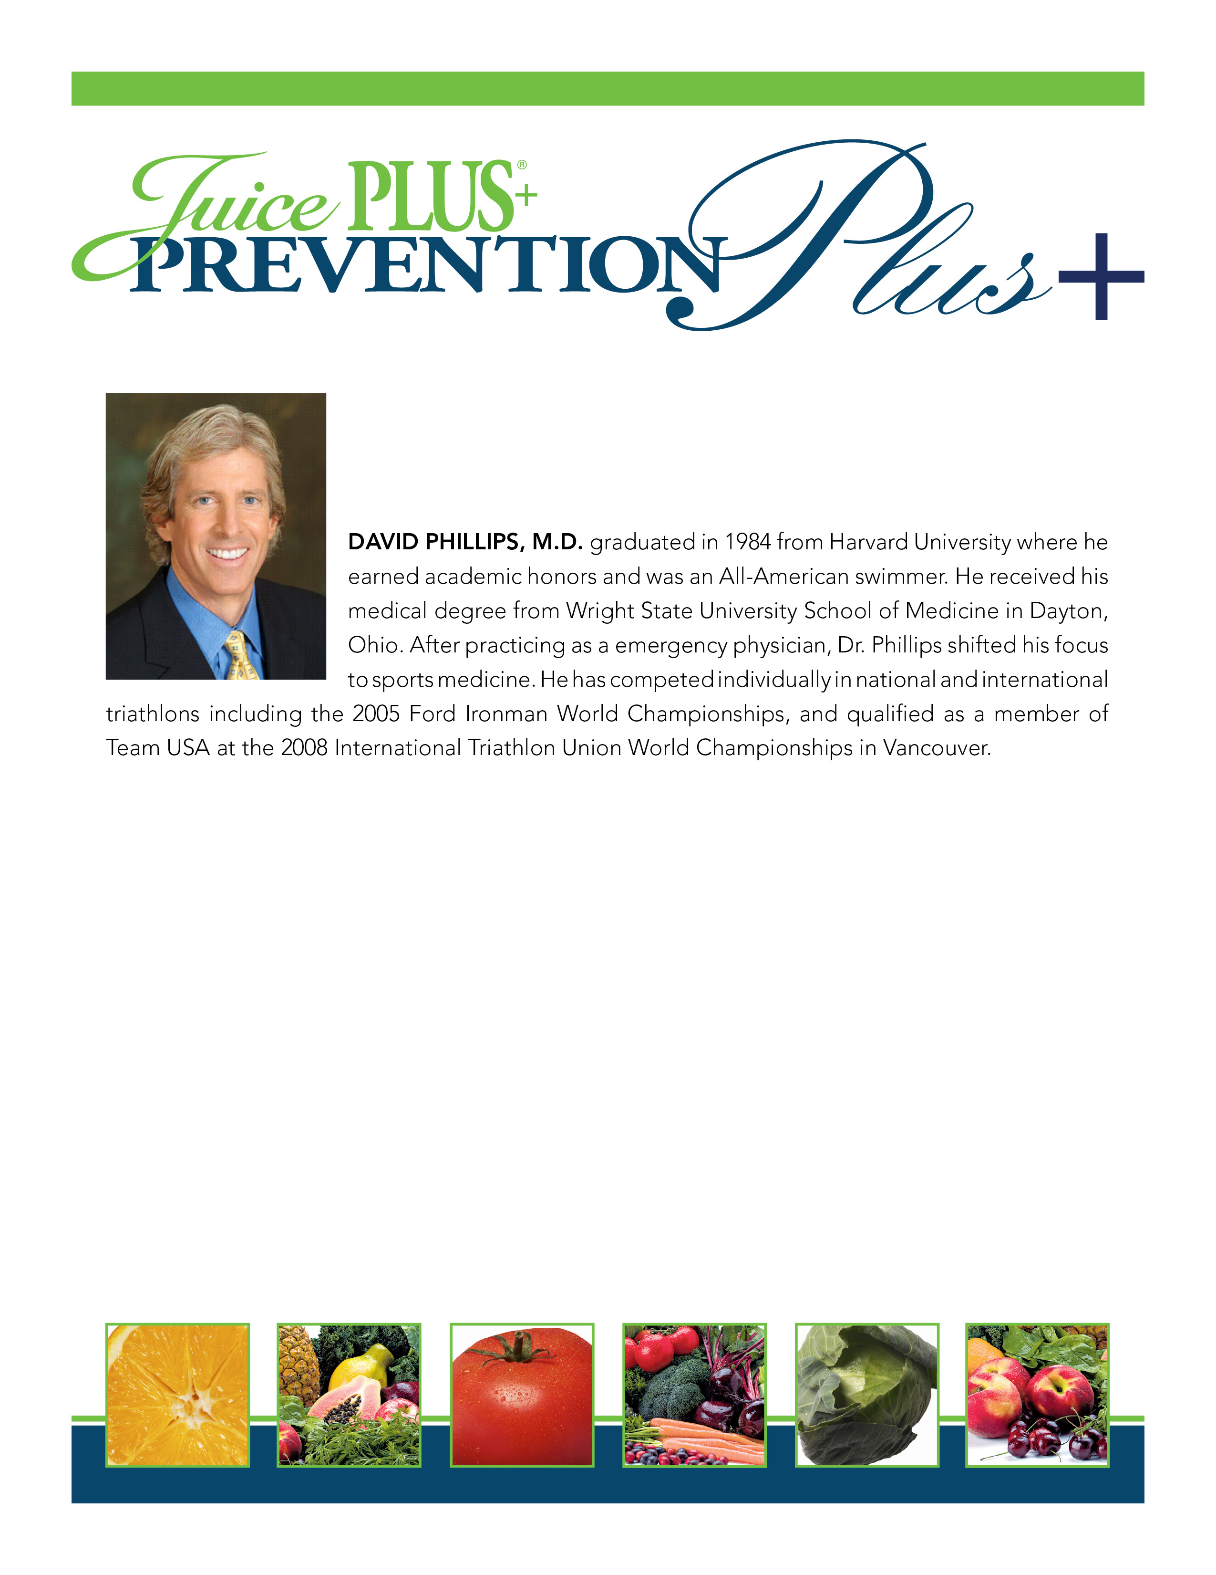

Thursday, March 21, 2013
7:00 – 8:00 PM
Crystal Lake Holiday Inn ~ Willow Room
800 South Route 31; Crystal Lake, IL 60014
Please enter through the Banquet Doors (side doors of the hotel under awning)

FREE for Guests of Valerie Early, RD and Frank Grad, Wellness Advisor
www.nutritionconnectionbalance.com
For more information and to register: Rosanne at 847-985-1200
“Journey to a Healthy Existence”
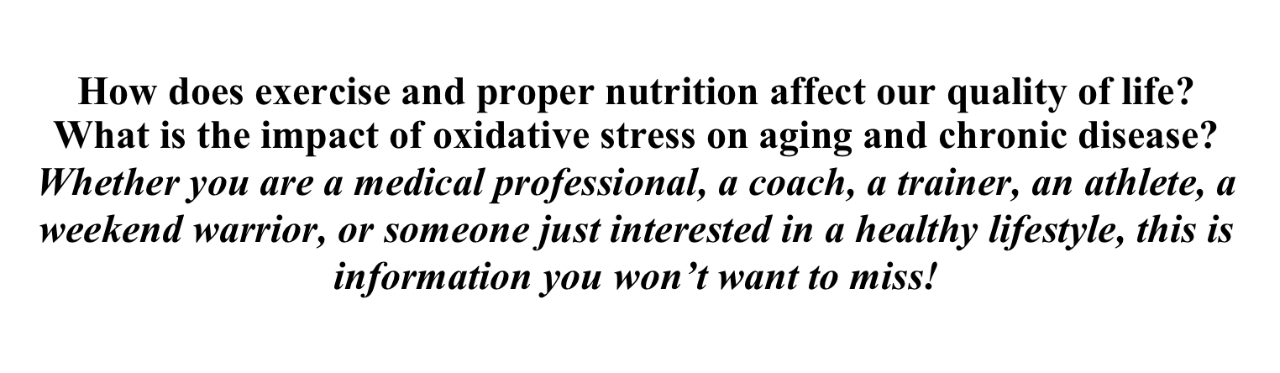
How does exercise and proper nutrition affect our quality of life?
What is the impact of oxidative stress on aging and chronic disease?
Whether you are a medical professional, a coach, a trainer, an athlete, a weekend warrior, or someone just interested in a healthy lifestyle, this is information you won’t want to miss!

